Electronic Appendix D for the article: "Geology, geochronology and geochemistry of the 2.05 Ga gneissic A1-type granites and related intermediate rocks in central Finland: implication for the tectonic evolution of the Karelia craton margin"
by Kärenlampi et al. (2019) Bulletin of the Geological Society of Finland

Contents
1. Geological descriptions of the Otanmäki-Kuluntalahti nappe and Lehtovaara lens
2. Petrographic descriptions of Otanmäki suite A-type rocks
3. References
1. GEOLOGICAL DESCRIPTIONS OF THE OTANMÄKI-KULUNTALAHTI NAPPE AND THE LEHTOVAARA LENS
1.1 Western segment
The western segment comprises mostly of coarse-grained, clinopyroxene- and/or amphibole-bearing alkali feldspar (AF) granite, syenite and monzonite-monzodiorite, generally occurring in separate blocks (0.5–5 km²) with sharp boundaries. Occasionally, in outcrops, the syenite blocks are observed contain small patches (~10–20 m²) of AF granite, but with unexposed contacts. The AF granite and intermediate rocks also contain sporadic mafic enclaves up to a meter in size. In the central part of the segment, fine-grained, subvolcanic-like biotite monzogranite occurs in one large (16 km²) and a few smaller (1–3 km²) blocks, the largest of these enclosing up to 200-m-thick and 5-km-long slivers of Lower Kaleva-type metapsammite-pelite schists (Fig. 1a; Finnilä, 2000). Drillcore intersections reveal, that the monzogranite-metasediment contacts are marked with thin zones of calc-silicate rocks (~1 m thick) that could represent synemplacement metasomatic reaction rims developed at intrusive contacts. The contacts between the monzogranite and the coarse-grained A-type rocks are difficult to establish, as in the observed cases, the contacts have been reworked during the Svecofennian orogeny. The western segment A-type rocks and enclosed metasediments are also intruded by mafic dike rocks (~3–15 m thick and pervasively amphibolitized) of Fe-tholeiitic affinity.
Minor gabbroic intrusions (0.5–7 km²) occur in the Archean gneiss complexes, near the southern and western contacts of the western segment. In outcrops, these gabbro bodies are highly variable in their grain size and color index, comprising mostly melanogabbros and leucogabbros with rounded to angular bodies of leucogabbro-anorthosite. They host a remarkably large volume of vanadiferous magnetite-ilmenite-rich ore bodies given their small sizes (Lindholm & Anttonen, 1980). The two largest of the intrusions (named Otanmäki and Vuorokas) have been dated at 2058 ± 15 Ma (Huhma et al., 2018), and thus broadly taken coeval with the 2.05 Ga A-type rocks. The gabbros and A-type rocks are in a fault contact, which is exposed at the northern margin of Otanmäki gabbro intrusion and based on drillcore intersections, is nearly vertical at least to a depth of 500 m. No evidence for intercalation of gabbros and A-type rocks is found at this boundary, but both the Otanmäki and neighboring Vuorokas gabbros are intruded by yet undated granite dikes (~1 m thick) that have A-type trace element chemistry. The Otanmäki and Vuorokas gabbro bodies are also intruded by mafic dikes, some of them having alkali basaltic composition (Nykänen, 1995). Both at Otanmäki and Vuorokas, the attitudes of the mafic dikes are near vertical, which indicates that the gabbro bodies have not experienced any major postemplacement tilting.
At the northern margin of the western segment, at Kemiläistenräme, a tectonic sliver (10x0.5 km) composed of metagabbroic-leucodioritic gneisses is found. This mafic unit is undated, but importantly, it is intruded by A-type granite dikes (1 to 10-m-thick), which are also undated, but are have mineralogically and texturally very similar to the syeno- and monzogranites occurring in the Otanmäki suite nappes.
1.2 Central segment
The central segment has a zoned structure in which coarse-grained AF granite form the central part (~35 km²) and fine-grained syenogranite the outer parts (~50 km²). The structure may be essentially magmatic or perhaps involve stacked thrust sheets, but the contacts between the two granites are generally unexposed, making it difficult assess the relationship. The AF granite is amphibole- and/or biotite-bearing and commonly does not contain enclaves. The syenogranite member contains amphibole and biotite, and in places grades into texturally similar biotite monzogranite. The syenogranite occur frequently with amphibolite-calc-silicate rock enclaves that are up to a few meters across (Fig. 1b–c). Enclaves of similar supracrustal rocks are found in Otanmäki suite A-type granites in the eastern segment and Lehtovaara lens (see below).
At the western to central segment transition the Otanmäki-Kuluntalahti nappe is narrow and covered by waters of Lake Oulujärvi. At the eastern margin of the central segment, the coarse-grained AF granite of the central segment grades abruptly to subvolcanic-like AF granite, which is a major component of the eastern segment. Furthermore, at the northern margin of the central segment, at Vuorijärvi, we have observed a small mafic rock unit (6x1 km) similar to that found at the northern margin of the western segment (at Kemiläistenräme). The Vuorijärvi mafic unit is intruded by A-type rocks (mainly syenite), in form of small lenses or dikes few tens to hundred meters wide.
1.3 Eastern segment
The eastern segment is composed mainly of fine-grained and either even-grained or quartz ± potassium feldspar phyric biotite-bearing AF granite, which towards the central part of the segment grades to a slightly coarser-grained type, which contains abundant potassium feldspar phenocrysts. A minor type is a medium- to coarse-grained amphibole- and/or clinopyroxene-bearing syenogranite, forming two small bodies (2x3 km and 1.5x0.5 km) unexposed for their contacts in the northern part of the segment. In the eastern part of the segment, the fine-grained AF granite intrudes with meandering contacts into a “Jatuli-type” sequence of mainly orthoquartzites with intercalations of mafic volcanic rocks and sills. Furthermore, the AF granite in the southern part of the segment enclose inliers, which contain quartzite-dolomite with mafic volcanic rock intercalations, and also small separate inliers (<0.5 km²) with rocks uncommon for the Jatulian sequences in the Kainuu schist belt (Laajoki, 2005). The latter include include rhyolite breccias, dominantly rhyolite-clastic conglomerates (Fig. 1d), and blocky volcaniclastic rocks that could represent sediment-rhyolite mingling deposits (peperites; Fig. 1e) along the contacts of the AF granite. Besides peperites in the southern part, there are frequent several-m-thick developments of calc-silicate rocks at contacts between dolomites and AF granites (Fig. 1f), whereas quartzites and amphibolites at AF granite contacts record minimal modification.
1.4 Lehtovaara lens
The Lehtovaara lens is separated from the Otanmäki-Kuluntalahti nappe by a narrow fault-bound belt of intercalated metabasalts-gabbros and metasedimentary rocks, the latter composed of alternating layers of garnet metawacke-pelite and sulfidic-graphitic metawacke-pelite with quartzitic interbeds, which is a common rock assemblage in the Lower Kaleva (Laajoki, 2005; Kontinen & Hanski, 2015). In the western part of the intervening metasedimentary belt, there is a small (2x3 km) unit of psephitic slump/debris avalanche deposits composed mainly of metagabbroic-basaltic clasts (Fig. 1g–h), and which has no obvious counterpart or observed sources elsewhere in the Kainuu schist belt. In the south and east, the Lehtovaara structure is bordered by faults against the flanking Archean TTGs. In the east, the lens is fault-separated from a belt of quartzites similar to those of the autochthonous Jatuli formations of the Kainuu schist belt (Laajoki, 2005). Superficially similar quartzites are found inside the Lehtovaara lens, where they are intruded by two types of A-type granite. An apparently older granite phase is represented by fine-grained, subvolcanic-like biotite monzogranite, which encloses small inliers (<0.2 km²) of dolomite, tremolite-diopside skarn, rhyolite-peperite (Fig. 1i), and mafic and high-K intermediate metavolcanic rocks. The other, apparently younger phase is a medium- to coarse-grained, amphibole- and/or biotite-bearing AF granite, mineralogically and chemically very similar to the coarse-grained AF granite of the central segment.
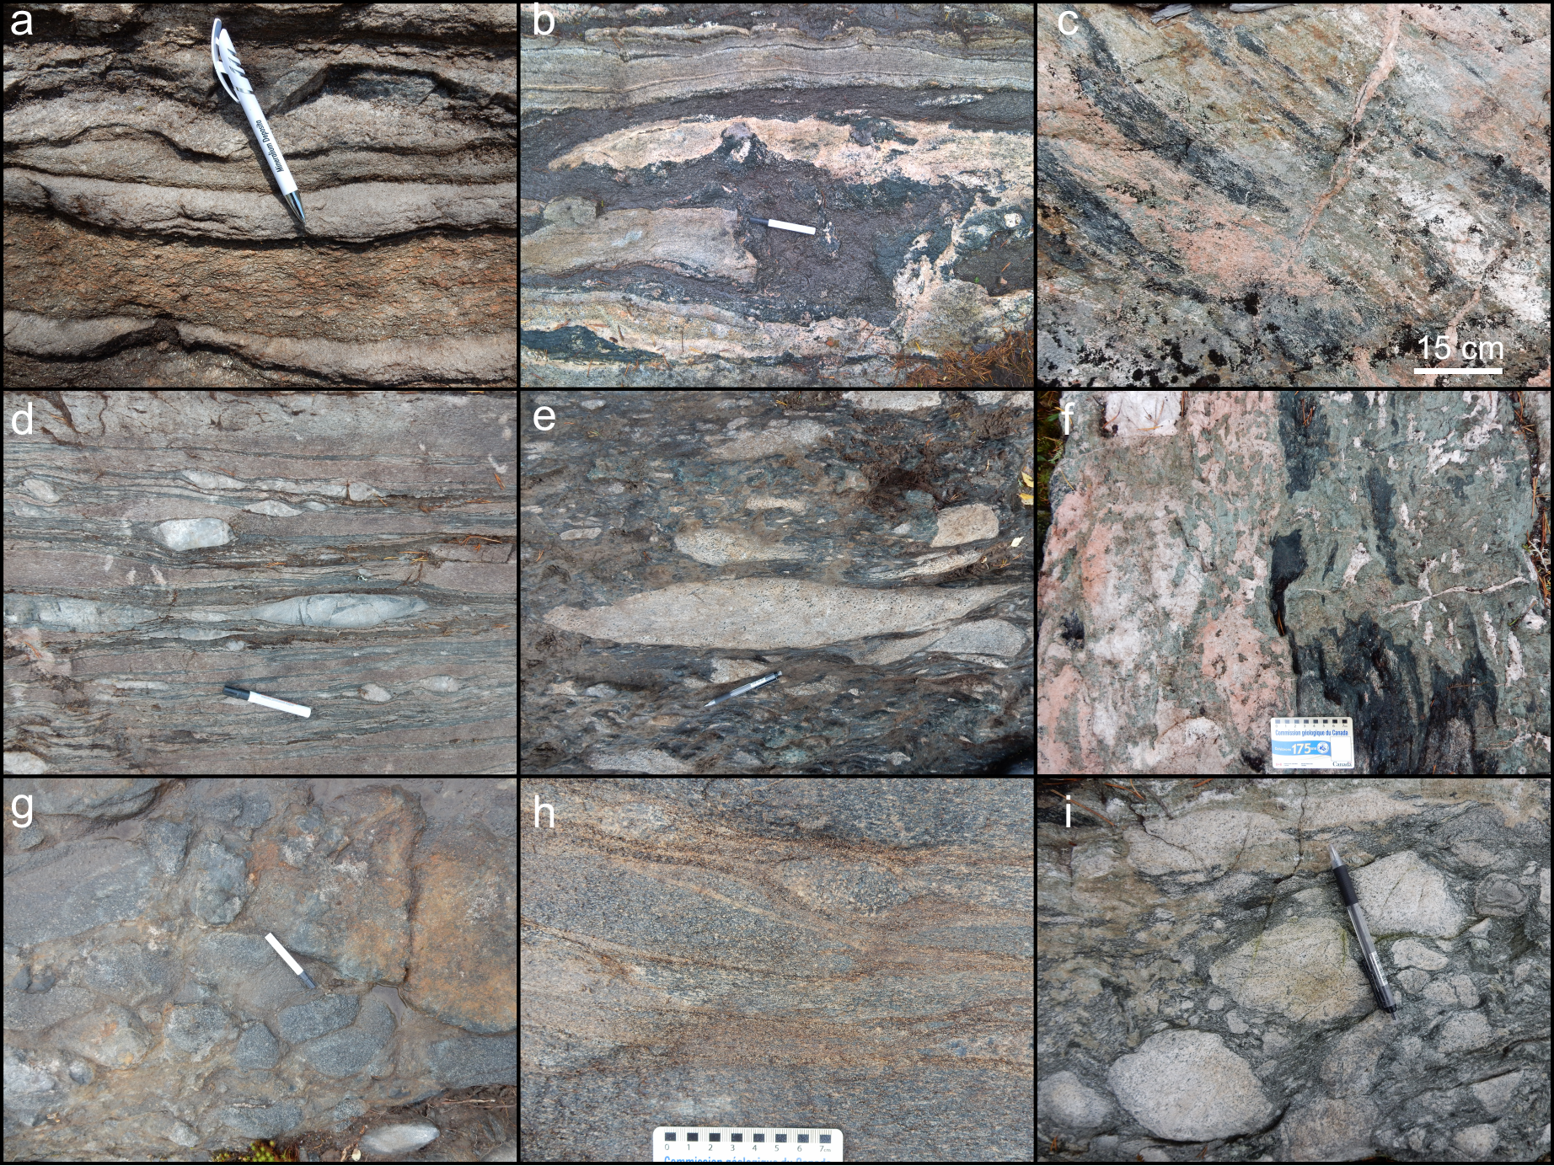
Fig. 1. (a) Metapelite (dark-grey) with psammitic (light-grey) intercalations, western segment; (b–c) amphibolite-calc-silicate rock enclaves in syenogranite, central segment; (d) conglomerate with rhyolite (reddish-brown) and quartzite (light-grey) clasts, eastern segment; (e) rhyolite peperite with rhyolite fragments (light-grey) and calc-silicate matrix (dark greenish-grey), eastern segment; (f) calc-silicate rock and amphibolite occurring in contact with alkali feldspar (AF) granite, eastern segment; (g–h) psephitic slump/debris avalanche deposits composed mainly of metagabbroic-basaltic clasts, western part of the metasedimentary belt located between central segment and Lehtovaara lens; (i) rhyolite-peperite, with rhyolite fragments (light-grey) and calc-silicate matrix (dark greenish-grey), Lehtovaara lens. Pencil and marker lengths in (a), (b) (d), (e), (g), (i) is 15 cm. Scale bar length in other figures is in cms.
2. PETROGRAPHIC DESCRIPTIONS OF THE OTANMÄKI SUITE A-TYPE ROCKS
2.1 Alkali feldspar granites
The alkali feldspar (AF) granites are composed mostly of alkali feldspars (potassium feldspar and albite (An₀), combined ~60–70 vol.%) and quartz (~25–35 vol.%). The alkali feldspars occur as separate grains and lack perthite. Titanite, zircon, allanite, fluorite, apatite, Fe-Ti-oxides and calcite are common minor phases. Clear differences between AF granites are observed in the proportions and types of mafic phases and textures found in them in different parts of the suite.
In the western segment, the peralkaline-metaluminous AF granites have coarse-grained, inequigranular (~0.5–5 mm) textures. They contain typically ~5–20 vol.% of clinopyroxene and/or amphibole, which occur in bands/aggregates and form gneissic fabric with foliation and/or lineation. Amphibole appear mostly as complete or partial overgrowth/replacement over fragmented clinopyroxene, which could be primary magmatic mineral. Biotite is rarely present. Magnetite content is variable and both magnetic and weakly magnetic variants are found. Zircon occur as stubby, euhedral crystals up to 200–500 µm in longest dimension.
The peraluminous AF granites in the central segment and Lehtovaara lens and have coarse-grained, inequigranular (~0.2–10 mm) and intensively foliated and lineated fabrics, with lineation being often more strongly developed than foliation. Amphibole (~0–5 vol.%) and biotite (~10 vol.%) occur as mafic phases, typically in fine-grained (<1 mm) aggregates/bands. The central segment AF granites have very low magnetic susceptibility and they lack magnetite. Zircon occurs as large (ø ~100–400 µm) but sparsely distributed euhedral-subhedral crystals.
The eastern segment AF granites (peraluminous) are relatively fine-grained (<1 mm) and either equigranular or contain quartz and/or potassium feldspar phenocrysts (ø 3–12 mm), with a foliated and lineated gneissic fabric. They lack amphibole and clinopyroxene, but contain biotite and magnetite (combined ~1–8 vol.%). Biotite is often altered to chlorite. Zircon is plentiful as small (ø ~20–50 µm), stubby crystals.
In hand sample, the coarse-grained AF granite variants are brown, reddish brown or pinkish-grey in color, whereas the fine-grained variants are reddish- or pinkish-grey.
2.2 Syeno-monzogranites
The syeno- and monzogranites across the suite are texturally and mineralogically very similar to each other and a close genetic connection between them is supported by similar chemistry. Both rock types are peraluminous and have fine-grained (<1 mm) and equigranular textures, or locally contain zones rich in few mm sized spots composed of potassium feldspar agglomerations, which probably were originally phenocrysts.
Major minerals in the syeno- and monzogranites are potassium feldspar (~30–40 vol.%), calcic (An_{10–60}) plagioclase (~20–30 vol.%) and quartz (~30–35 vol.%) and mafic silicates (~5–20 vol.%). In both granite types, the feldspars form separate grains and intergrowths are not observed. The monzogranites contain biotite, whereas syenogranites contain both biotite and amphibole. Both granite types have elevated magnetic susceptibility and contain disseminated magnetite. Other minor phases include titanite, muscovite, chlorite, apatite, zircon, allanite, calcite and garnet (rare). In addition, some syenogranites occasionally contain epidote or clinopyroxene as minor minerals. Zircon crystals are 50–200 µm in size.
In hand sample, the syenogranites are pinkish-grey or grey and monzogranites dark-grey in color and both have a gneissic fabric with foliation and/or lineation.
2.3 Syenites
The Otanmäki suite syenitic (peralkaline, metaluminous or mildly peraluminous) rocks are compositionally variable, consisting of varying proportions of potassium feldspar (~30–60 vol.%), sodic or calcic (An_{0–10}) plagioclase (~30–45 vol.%), quartz (~0–10 vol.%) and mafic silicates (combined ~5–25 vol.%) with their modal composition ranging from variably amphibole-, clinopyroxene- and/or biotite-bearing quartz AF syenite, AF syenite and quartz syenite. The feldspars in the syenite variants occur as separate grains and lack intergrowths. Magnetite content is variable and syenites with non-magnetic and magnetic character are found. Zircon is scarce and occurs as tiny (ø ~10–50 µm) inclusions in amphibole or biotite grains. Other minerals present include titanite, apatite and allanite. Most syenites have fairly equigranular, medium- to coarse-grained (~0.5–4 mm) feldspar-dominated microstructures separated by elongated agglomerations of mafic silicates, which define a gneissic fabric.
In hand sample, the syenites have either greenish brown, grey or pinkish-grey color and a mottled/banded appearance with foliation and/or lineation.
2.4 Monzonites and monzodiorites
The monzonitic and monzodioritic rocks occur only in one locality in the western segment where they grade to each other without sharp boundaries. They are variably either pinkish dark-grey or light-grey colored as there are also variants, which contain significantly less mafic minerals. The monzonitic-monzodioritic rocks have fairly coarse-grained, inequigranular (grain size ~0.2 to 5 mm) and foliated textures. They consist dominantly of separate grains of calcic (An₁₀) plagioclase (~15–40 vol.%) and potassium feldspar (~15–35 vol.%) and variable proportions of amphibole (~5–20 vol.%), biotite (~5–20 vol.%), Fe-Ti oxides (~2–5 vol.%) and titanite (~1–5 vol.%). Other minor phases include apatite (~1 vol.%), pyrite (~0–1 vol.%), quartz and zircon. Zircon occurs in very small amounts, typically as tiny (ø ~30 µm) inclusions in biotite flakes.

3. References

Finnilä, J., 2000. Provenance and paleoweathering of the early Proterozoic metasediments in the western parts of Kainuu and Kuusamo schist belts. M.Sc. Thesis, University of Oulu, 90 p. (in Finnish)
Huhma, H., Hanski, E., Kontinen, A., Vuollo, J., Mänttäri, I. & Lahaye, Y., 2018. Sm–Nd and U–Pb isotope geochemistry of the Paleoproterozoic mafic magmatism in eastern and northern Finland. Geological Survey of Finland, Bulletin 405, 150 p.
Kontinen, A. & Hanski, E., 2015. The Talvivaara black shale-hosted Ni-Zn-Cu-Co deposit in eastern Finland. In: Maier, W. D., Lahtinen, R., O’Brien, H. (eds.), Minerals Deposits of Finland. Elsevier, Amsterdam, pp. 557−612. https://doi.org/10.1016/B978-0-12-410438-9.00022-4
Laajoki, K., 2005. Karelian supracrustal rocks. In: Lehtinen, M., Nurmi, P., Rämö, T. (eds.), The Precambrian Bedrock of Finland – Key to the Evolution of the Fennoscandian Shield. Elsevier Science B.V., Amsterdam, pp. 279–342. https://doi.org/10.1016/S0166-2635(05)80008-8

Lindholm, O. & Anttonen, R., 1980. Geology of the Otanmäki Mine. In: Häkli, T.A. (ed.), Precambrian Ores of Finland, Guide to Excursions 078 A + C, Part 2 (Finland). Proceedings of the 26th International Geological Congress. Geological Survey of Finland, Espoo, pp. 25–33.

Nykänen, V., 1995. Crystallization and chemical evolution of the lower- and central part of the Vuorokas block in the Otanmäki intrusion complex. Licentiate Thesis, University of Oulu, 135 p. (in Finnish)

