Please write title here

A.A. Author1\*, B.B. Coauthor2, C.C. Coauthor2

*1Department of Authors, University of Authors, Authortown, Authorland*

*2Department of Coauthors, University of Coauthors, Coauthortown, Coauthorland*

*\*corresponding author: a.author@mail.com*

Introduction

Content starts from here, first paragraph without an indent. Please replace all text and titles with your own, but remember to keep the formatting as given here.

Next paragraph starts with an indent like here.

Other important things to consider

The maximum length of the abstract is 1 page. It is possible to include figures and tables, but they should also fit within the 1-page-limit. The size of the abstract should not exceed 2 Mb. Please reduce the resolution of large figures.

References can be added (Author et al., 1981; Author & Coauthor, 2001) or see Author et al. (1981) and Author & Coauthor (2001), but they should also fit within the abstract limits. Citations follow a common Springer protocol such as for Mineralium Deposita (<https://www.springer.com/journal/126/submission-guidelines#Instructions%20for%20Authors_References>), but journal names are not abbreviated (see examples below). If there are more than six authors, “et al.” can be added after the fifth author.

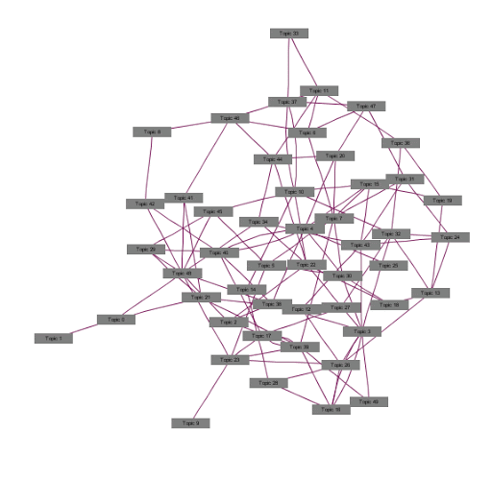

Figure 1. This is an example figure with an example caption. If there are subfigures, use small lettering (i.e. a, b…; also when referring in the text: e.g., Fig. 1a). Tables use a similar caption, but placed above the table.

References

Author AA, Coauthor BB, Coauthor CC (1981) This is how we write an abstract. Journal of Authorship 53, 189−202.

Author AA, Coauthor BB (2001). This is how we write an abstract – a revision. In: Author AA, Coauthor CC (eds) Writing abstracts, 3rd edition. Publisher, Publishingtown, Publishingland, pp 230−257.